Hospital Emergency Room (ER) Management System Project

Project Overview:
The Hospital provides emergency room services to patients across various departments. During the reporting period, there were a total of 9,216 patients visits in the Emergency Room. Out of 9,216 patients 4,612 patients were admitted for further treatment and 4,604 patients were not admitted.
The management wanted to understand the reasons behind the high number of non-admitted patients and identify factors affecting patient flow, wait times and overall ER performance. They were also facing challenges in managing resources and emergency room capacity efficiently.

As Management Information System(MIS) Executive I have done following steps to make the management system effortlessly:

Data Cleaning and Transforming:
I fetched data from hospital’s main source system and import it into Excel for further analysis and reporting.
I validate the data checking null values and removing them, checking duplicate records and transforming the data into a suitable format for reporting using Power Query. By using Power Query I made new columns, use conditional functions to analyze the data based on criteria.

Creating Reports for Performance Analysis:

- Monthly Performance Report:
Created this monthly report to understand patient visit patterns throughout the month, so for that I divided each month into three periods( Start of Month 1st to 10th), (Mid of month 11th to 20th), (End of Month 21st to Month End)

Findings:
32% of patients visited during the first 10 days.
33% of patients visited during the middle period.
35% of patients visited during end of the month.

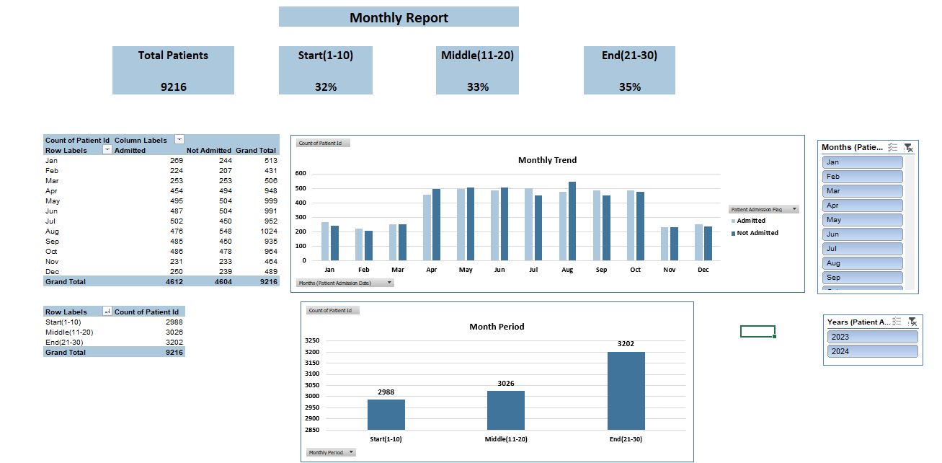
This report shows that patient visits are slightly higher during the end of the month. Therefore, I recommended that management should plan additional staff and resources during the month-end period to manage patients more efficiently.

- Weekly Performance Report:
I created a weekly report to understand patient visits across different days and weeks.

Findings:
Saturday recorded the highest patient count with 1,377 patients.
Wednesday had the lowest patient count with 1260 patients.
Week 4 showed the highest patient engagement compared to other weeks.

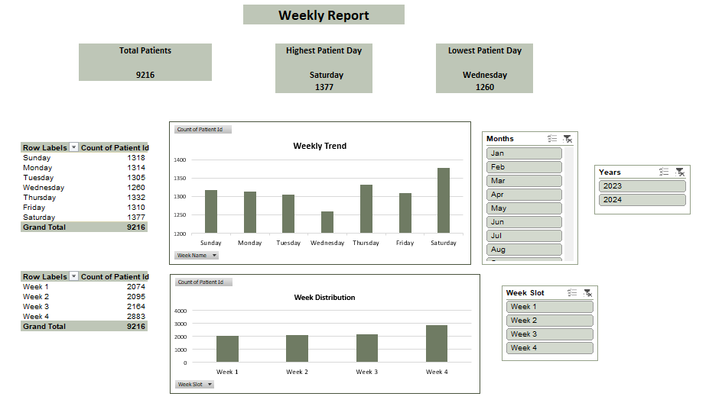
Based on these findings, I suggested that the hospital should allocate more staff on Saturdays and during Week 4 to ensure smooth patient handling and reduce operational pressure on the emergency room.

- Daily Performance Report:
I created a daily performance report to monitor patient visits on a day-to-day basis.

Findings:
I performed a time-slot analysis to identify the busiest periods of the day. The analysis shows that almost all the time slots experienced equal patient traffic indicating that patient flow remained consistent throughout the day.

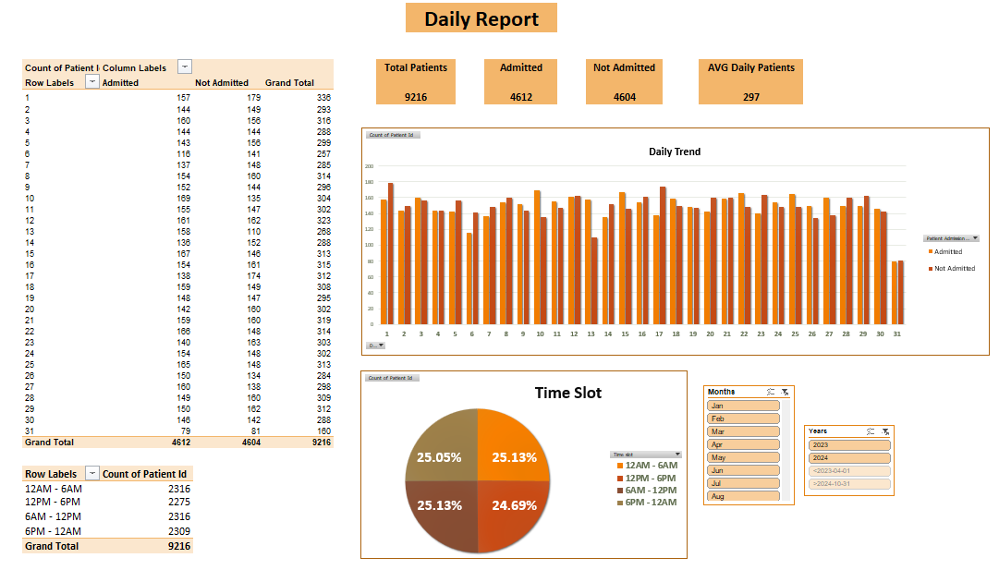

- Wait Time Analysis:
To understand service efficiency, I categorized patient wait times into three groups:
Within Target (<30 Mins)
Slightly Above Target (<=45 Mins)
Much Higher (>45 Mins)

Findings:
41% of patients were attended within the target wait time.
59% of patients were attended above the target wait time.
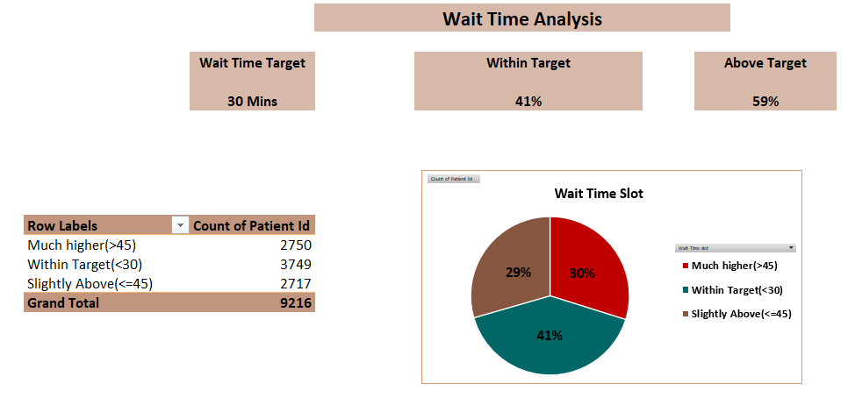
Since more than half of the patients experienced wait times above the target, management should focus on improving resource allocation and staffing in high-demand areas to reduce delays and improve patient experience.

Dashboard Overview:
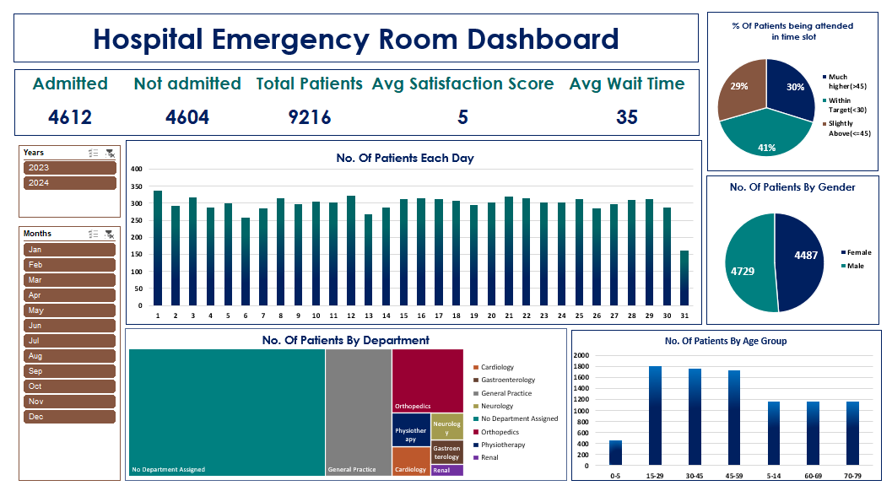

The Hospital Emergency Room Dashboard provides a quick overview of 9,216 patient visits with 4,612 admitted and 4,604 not admitted patients. The hospital recorded an average satisfaction score of 5 and an average wait time of 35 minutes. Most patients belonged to the 15-59 age group and only 41% of patients were attended within the target wait time, highlighting opportunities to improve service efficiency and resource allocation. The dashboard helps management monitor patient flow, department performance and key operational KPI’s for better decision-making.

